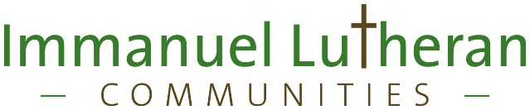

You can have a socially meaningful job as part of our non-profit mission to our neighbors who need help with ADL's (the Activities of Daily Living).

Be part of our nursing team, by earning your certification as a Certified Nursing Assistant, a "CNA", and then being a team member in our skilled nursing care or post-surgical care areas.

We will hire you (and pay you) to work full-time while you train in our in-house, no-cost ("free") CNA training program.

We offer spots in this program to those committed to being part of our nursing team, full-time, for at least one year once they certify as a CNA.
- Immanuel is state-licensed to train CNAs at our facility.
- We have a class each month, and hire future team members for the class and employment as CNA’s as we meet them.
- You can join our nursing team now, as a Personal Care Assistant (a "PCA"), and learn & earn while you train. Being a PCA will give you a chance to learn some of the CNA skills before the class starts, and to 'test drive' a hands-on nursing team healthcare career.
- Once the CNA training starts, your job will become a mix of classroom work, recommended study and hands-on care with our residents.
- Successful graduates of our 3 week training program are eligible to take Montana's CNA exam, which is also done here (at no cost to you) at Immanuel.
- Upon passing the State test, most students will be offered a full-time position as a CNA at Immanuel.
Once you earn your CNA certification:
- Team members are assigned to full-time position on one of our 8 or 12-hour shift teams, but may volunteer for extra hours on other shifts.
- Our 12-hour teams work 7-7, with 4 days on followed by 4 days off.
- Even mix of weekends on and off-shift.
- We have 8-hour shifts in our new assisted living memory care (dementia care) for those chosen for this unique care setting.
- You will earn a competitive wage, with extra pay for night shifts.
- Tuition scholarships are available after 6 months of full-time employment, which can be ideal for those planning to attend an RN or LPN training program.
We offer health insurance for $50/month to full-time team members. Those taking our Healthy Choices Pledge receive a bonus, which serves to reduce this cost to $25/month.

We are a smoke & tobacco-free (including no e-cigs) campus, and a drug-free employer.
All pre-employment drug & TB testing, and the required annual flu shot, are provided at no cost.

If you are considering joining our nursing team and are interested in our in-house CNA training program, we encourage you to come in to see us, tour our living areas, talk to our nursing team leaders and complete an application.

We are at 185 Crestline Ave., Kalispell: two blocks south of the KRMC emergency room and helipad. You can also call our HR group for more information, at 406.752.9246.

