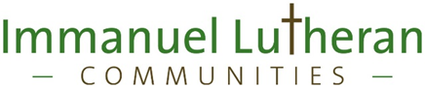
$500/Semester Scholarships – Nursing Students
Have you completed pre-reqs, and are now in the LPN or RN nursing program?
Do you have a current CNA license?
If “Yes” to both of these, you can be paid to work part-time, plus be immediately eligible for $500/term in tuition reimbursement.

We want nursing students with CNA certs who will work at least three 8 or 12-hour shifts/month.
You can get more shifts if you want more.
Most or all of these shifts will be weekends. You work with our Scheduler to agree on mutually convenient shifts as each month’s schedule is determined.
The work would be in our Skilled Care Center or Post-Acute.

Base pay is $13.00/hour (more for experienced CNA’s) + $1/hour for weekend hours + $1.50/hr. evening or $1.75/hr night differential + $500/term in tuition reimbursement.

Non-CNA Nursing students: We also have a limited number of Personal Care Assistant (no CNA cert required) in our Assisted Living and Assisted Living Dementia Care areas. The pay is $11.20 per hour + shift & weekend differentials + tuition reimbursement.

Other students, including those working on nursing pre-reqs:
- We have full and part-time openings for CNA’s & PCA’s, and Dining staff
- Competitive pay
- Eligible for up to $1000/term in tuition reimbursement after 6 months of full-time or 12 months of part-time employment.

We are at 185 Crestline. That’s 2 blocks south of the hospital, on Buffalo Hill.
For more details, please call LorNa, our Human Resources Generalist, at 406-752-9144.

